**Fitting Data to Probability Distributions Using Maximum Likelihood Estimate (MLE)**

Mahshid Jafarpour, Mehdi Sadeghi

Georgia Institute of Technology, USA

**Abstract**

The DistFit package is a Python toolkit designed for distribution fitting and goodness-of-fit testing. It facilitates the estimation of Maximum Likelihood Estimation (MLE) parameters for a wide range of probability distributions, as well as the assessment of how well a given distribution fits a set of observed data, Chi-Square goodness of fit. The package is adept at handling both discrete and continuous distributions, offering users a flexible and powerful tool for conducting in-depth statistical analyses. The implemented distributions include Bernoulli, Binomial, Geometric, Poisson, Uniform, Exponential, Normal, Weibull, and Gamma. This paper serves as a comprehensive guide to DistFit, delving into details about each distribution type it accommodates the underlying parameters utilized in the fitting process. The MLE approach is employed to estimate the parameters of these distributions, enabling users to gain insights into the underlying nature of their datasets.

Furthermore, the DistFit package includes an illustrative examples file showcasing the seamless integration of these modules in practical scenarios. Users can visualize the fitted distributions, explore possible alternatives, and conduct hypothesis tests to assess the adequacy of the chosen distribution.

Key features of DistFit include a user-friendly interface, flexibility in handling diverse distribution types, and efficient algorithms for parameter estimation. The package serves as a valuable asset for researchers, data scientists, and analysts seeking a robust and versatile toolkit for distribution analysis and hypothesis testing in Python.

1. **Introduction**

At the core of DistFit is the MLE methodology, a robust statistical technique employed to optimize the parameters of probability distributions by maximizing the likelihood of the observed data. This principled approach allows users to obtain precise estimates for distribution parameters, facilitating a profound understanding of the intrinsic characteristics of their datasets.

The Goodness of Fit (GoF) module within the DistFit package plays a crucial role in evaluating how well a probability distribution model fits observed data. This module utilizes statistical tests to compare the observed data against the theoretical distribution, helping users make informed decisions about the appropriateness of the chosen model for their dataset. Through GoF analysis, DistFit empowers users to assess the validity of the fitted distribution, providing valuable insights into the quality of the modeling process.

The package caters to a broad spectrum of statistical needs, providing users with the capability to model discrete phenomena, such as binary outcomes, counts, and event occurrences, as well as continuous variables, including time intervals and measurements. DistFit not only equips users with the means to fit their data accurately but also empowers them with insightful visualizations, enabling the exploration of how well the chosen distribution aligns with the observed data.

This paper endeavors to guide users through the functionalities of DistFit, offering an in-depth exploration of each supported distribution type. From the Bernoulli distribution, modeling binary events, to the intricate parameters governing the Weibull and Gamma distributions for continuous data, DistFit is designed to cater to a diverse range of statistical scenarios. This paper aims to empower users to make informed decisions about the most suitable distribution for their specific datasets.

1. **Methodology**

DistFit is organized into three distinct modules: datagen, distfit, and gof. These modules collectively form DistFit, providing a comprehensive suite for data generation, distribution fitting, and goodness-of-fit analysis. Additionally, an examples file complements DistFit's functionality, demonstrating real-world applications of the datagen, distfit, and gof modules. This file serves as a practical guide, illustrating how to use DistFit to analyze different datasets and distribution types. The examples showcase the versatility and effectiveness of DistFit in fitting distributions to data and assessing the goodness of fit. The subsequent sections will delve into the specific details of each module, elucidating their functionalities and contributions to the overarching capabilities of DistFit.

* 1. **datagen**

the datagen module within DistFit is dedicated to synthetic data generation based on specified probability distributions. This module provides a convenient way for users to create artificial datasets, mimicking the characteristics of various probability distributions. The primary purpose of the datagen module is to facilitate testing and experimentation with DistFit's distribution fitting capabilities.

* + 1. **Datagen**

The Datagen class initializes with parameters specifying the type of distribution, the desired number of rows (data points), and distribution-specific parameters. It supports a variety of distribution types, including Normal, Geometric, Binomial, Poisson, Exponential, Gamma, Weibull, Uniform, and Bernoulli.

Initialization Parameters are:

* dist_type: Type of probability distribution (e.g., 'Normal', 'Geometric', 'Binomial').
* row_count: Number of rows (data points) to be generated.
* par: Distribution-specific parameters. The format of parameters varies based on the distribution type.

The data_generation method in this module generates synthetic data based on the specified distribution type and parameters. It utilizes NumPy's random number generation functions for each distribution type.

* 1. **distfit**

The methodology implemented in the Fitting class of the DistFit Python package revolves around fitting data to various probability distributions using the Maximum Likelihood Estimate (MLE) method. The class encompasses both discrete and continuous distributions, offering a comprehensive toolkit for statistical analysis. The key components of the methodology involve Initialization, Guessing Distributions, and the utilization of various distribution types. Additionally, the process includes the application of the plot method to visually represent the fitted distributions in comparison to the data histogram

* + 1. **Initialization**

The class is initialized with a given dataset (data), which can be provided as a pandas DataFrame or a pandas Series. If the input is not a DataFrame, it is converted to the correct format.

Essential statistics about the dataset are computed during initialization, such as mean (mu), standard deviation (sigma), size (size), minimum value (data_min), maximum value (data_max), and the original data itself.

* + 1. **Guessing Distributions**

The ‘guess_distributions’ method determines the possible distributions based on the data type (discrete or continuous) and characteristics of the dataset.

For discrete distributions, it checks for specific conditions to identify Bernoulli distribution or selects from a predefined list of discrete distributions.

For continuous distributions, it considers all specified continuous distributions, adjusting the list based on the range of the dataset.

The methodology provides a systematic and versatile approach to fitting data to a range of distributions, empowering users with tools for exploratory data analysis and statistical modeling. The visualizations aid in understanding how well the fitted distributions align with the observed data.

* 1. **Gof**

The gof (Goodness of Fit) module in DistFit is crucial for assessing how well a chosen probability distribution fits observed data. It employs chi-squared test to evaluate the statistical significance of the difference between observed and expected frequencies. This module aids in validating the appropriateness of the selected distribution for a given dataset. To streamline this process, the "Gof" class, when used in conjunction with the "Distfit" class, offers a powerful tool for evaluating the fit of data to a specified distribution. This article provides a comprehensive guide on leveraging these classes for effective goodness-of-fit analysis.

The "gof" module is designed to assess the goodness of fit for a given dataset to a specified distribution. Following are the key components of this module:

* **Initialization**: Initializes the Gof class with the distribution type (dist_type) and its parameters (par). The class automatically determines the number of estimated parameters (s) based on the distribution type.
* **Frequency Calculation**: Calculates the frequency of the observed data within specified bin edges. This step is crucial for subsequent goodness-of-fit analysis.
* **Binning Optimization**: Optimizes bins by combining adjacent bins if the expected frequency is less than 5. It ensures a minimum of 3 bins even when frequencies are low.
* **Goodness of Fit Test**: Conducts a goodness-of-fit test using the chi-squared statistic. It generates expected data based on the specified distribution, calculates observed and expected frequencies, optimizes bins, and performs the chi-squared test.

The effectiveness of the goodness-of-fit analysis is amplified when used in conjunction with the "distfit" class. The "distfit" class, as previously discussed, efficiently fits data to a variety of probability distributions using the Maximum Likelihood Estimate (MLE) method.

* 1. **Supported Distribution Types and Tests**

DistFit is a useful Python package designed for efficiently fitting data to a variety of probability distributions using the Maximum Likelihood Estimate (MLE) method. The package supports both discrete and continuous distributions, providing users with a versatile tool for statistical analysis. Different datasets may exhibit varying characteristics, influencing the choice of an appropriate distribution.

In this section, we introduce the key distribution types supported by DistFit, some examples and results, each serving a unique purpose in modeling and understanding different types of datasets.

* + 1. **Continuous Distributions**
       1. **Uniform Distribution**

The Uniform distribution models outcomes with equal likelihood over a specified range. DistFit estimates the lower ('a') and upper ('b') bounds through the MLE method. This type of distribution is useful when each outcome within a range is equally likely, as seen in scenarios like random number generation.

To exemplify the functionality of the DistFit package, we conducted a comprehensive analysis of a dataset generated from a uniform distribution. The following code snippet outlines the process, showcasing the estimation of Maximum Likelihood Estimate (MLE) parameters, visualization of the fitted distribution, and a subsequent Goodness of Fit (GoF) test.

import DistFit.distfit as dft

import DistFit.datagen as dgn

import DistFit.gof as gof

# Generate data from a uniform distribution

data_dist = dgn.Datagen(dist_type='uniform', row_count=2000, par=(2.3, 4.1), seed=1)

data = data_dist.data_generation()

# Estimate MLE parameters using DistFit

model = dft.Fitting(data, dist_type='uniform')

a, b = model.fit()

print("The fitted MLE parameters are %.4f %.4f." % (a, b))

# Explore possible distributions using DistFit

possible_distributions = model.guess_distributions()

# Visualize the fitted uniform distribution

model.uniform_plot((a, b))

# Perform Goodness of Fit test using DistFit

gof_test = gof.Gof(dist_type='uniform', par=(a,b))

gof_test.gof(data)

The fitted MLE parameters are 2.3002 4.0973.

Note: only a limited number of distributions are considered in this library.

The possible distributions for the data are: ['Uniform', 'Exponential', 'Normal', 'Weibull', 'Gamma']

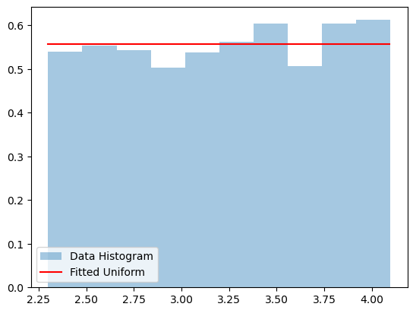

*Figure 1: Fitted Uniform distribution versus generated data histogram*

Test Statistics: 0.6157; Critical Value: 5.9915

Accept H0 that the distribution is a good fit at the given significance level.

True

In this demonstration, we generated a dataset with 2000 samples from a uniform distribution with parameters a=2.3 and b=4.1. The DistFit package efficiently and successfully estimated the MLE parameters (a and b), identified possible distributions, and visualized the fitted uniform distribution. It successfully identified the possible distributions for the given dataset as expected. The ability to accurately recognize potential distribution types is a crucial aspect of the package, providing users with valuable insights into the underlying nature of their data.

Furthermore, the GoF test confirmed that the fitted distribution is a good fit at the specified significance level, as indicated by the acceptance of the null hypothesis. This example showcases the robust capabilities of DistFit in fitting distributions and assessing their goodness of fit.

* + 1. **Exponential Distribution**

The Exponential distribution models the time between events in a Poisson process. DistFit estimates the rate parameter, '1/rate,' through the MLE method. It commonly applied in scenarios where the focus is on the time between events, such as the time between arrivals in a queue.

The code below, demonstrates the practical usage of the DistFit package for fitting data to an exponential distribution. It includes data generation, maximum likelihood estimation (MLE) parameter fitting, exploration of possible distributions, visualization of the fitted distribution, and a goodness-of-fit test. The printed MLE parameter, possible distributions, and the result of the goodness-of-fit test are displayed for analysis and interpretation.

import DistFit.distfit as dft

import DistFit.datagen as dgn

import DistFit.gof as gof

# Generate data from a uniform distribution

data_dist = dgn.Datagen(dist_type='exponential', row_count=2000, par=(0.35), seed=1)

data = data_dist.data_generation()

# Estimate MLE parameters using DistFit

# estimate MLE parameter

model = dft.Fitting(data, dist_type='exponential')

mle_param = model.fit()

print("The fitted MLE parameter is %.4f." %mle_param)

# Explore possible distributions using DistFit

possible_distributions = model.guess_distributions()

# Visualize the fitted uniform distribution

model.exponential_plot(mle_param)

# Perform Goodness of Fit test using DistFit

gof_test = gof.Gof(dist_type='exponential', par=mle_param)

gof_test.gof(data)

The fitted MLE parameter is 0.3593.

Note: only a limited number of distributions are considered in this library.

The possible distributions for the data are: ['Uniform', 'Exponential', 'Weibull', 'Gamma']

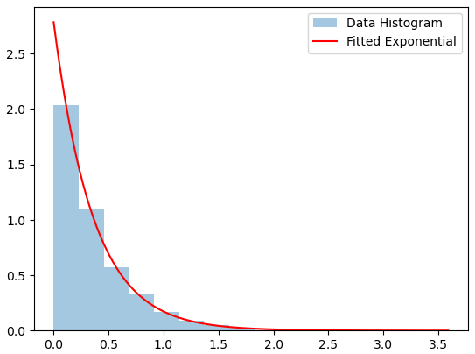

*Figure 2: Fitted Exponential distribution versus generated data histogram*

Test Statistics: 4.0574; Critical Value: 7.8147

Accept H0 that the distribution is a good fit at the given significance level.

True

The data with 2000 samples is generated from an exponential distribution with 1/rate parameter of 0.35. The MLE method estimates the parameter of the exponential distribution, and for the generated data, the fitted MLE parameter is found to be 0.3593 which is a correct estimation of observed parameter. DistFit explores various distribution types based on the nature of the data. For the generated dataset, the possible distributions considered include 'Uniform', 'Exponential', 'Weibull', and 'Gamma'.

The Goodness of Fit (GOF) test is included for the evaluation of how well the fitted distribution aligns with the observed data. In the provided example, the test statistic is calculated as 4.0574, and the critical value at a 5% significance level is 7.8147. The outcome of the test is conclusive, there is acceptance of the null hypothesis (H0) that the distribution is a good fit, given the significance level. Therefore, the fitted exponential distribution adequately represents the underlying nature of the generated data.

* + 1. **Normal Distribution**

The Normal distribution is a versatile distribution modeling a wide range of phenomena. DistFit estimates the mean ('mu') and standard deviation ('sigma') through the MLE method. It widely used in scenarios where data distribution is symmetric and follows a bell-shaped curve, like human height.

To showcase the practical application of the DistFit package on a dataset generated from a Normal distribution, we conducted a fitting and goodness-of-fit (GoF) analysis. The following Python code demonstrates each step of the process.

import DistFit.distfit as dft

import DistFit.datagen as dgn

import DistFit.gof as gof

# Generate data from a uniform distribution

data_dist = dgn.Datagen(dist_type='normal', row_count=2000, par=(3,2), seed=1)

data = data_dist.data_generation()

# Estimate MLE parameters using DistFit

# estimate MLE parameter

model = dft.Fitting(data, dist_type='normal')

mu, sigma = model.fit()

print("The fitted MLE parameter is %(m).4f %(s).4f." %{'m':mu, 's':sigma})

# Explore possible distributions using DistFit

possible_distributions = model.guess_distributions()

# Visualize the fitted uniform distribution

model.normal_plot(params=(mu, sigma))

# Perform Goodness of Fit test using DistFit

gof_test = gof.Gof(dist_type='normal', par=(mu,sigma))

gof_test.gof(data)

The fitted MLE parameter is 3.0661 2.0122.

Note: only a limited number of distributions are considered in this library.

The possible distributions for the data are: ['Uniform', 'Normal']

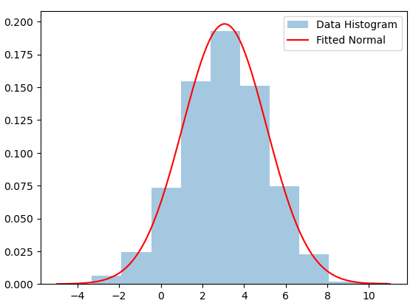

*Figure 3: Fitted Normal distribution versus generated data histogram*

Test Statistics: 4.1215; Critical Value: 5.9915

Accept H0 that the distribution is a good fit at the given significance level.

True

# perform Goodness of Fit test for uniform

# first fit data to uniform

model = dft.Fitting(data, dist_type='uniform')

gof_test = gof.Gof(dist_type='uniform', par=model.fit())

gof_test.gof(data)

Test Statistics: 1726.9527; Critical Value: 5.9915

Reject H0, the distribution is NOT a good fit at this significance level.

False

In this example, we generated synthetic data from a Normal distribution with a mean (μ) of 3 and a standard deviation (σ) of 2. We then utilized DistFit to estimate the Maximum Likelihood Estimate (MLE) parameters, explore possible distributions, and visually inspect the fitted Normal distribution.

The estimated Maximum Likelihood Estimate (MLE) parameters for the Normal distribution are the mean (μ) which is approximately 3.0661, and the standard deviation (σ) which is approximately 2.0122. All aligned with the parameters of the observed data.

DistFit explores and suggests possible distributions for the given dataset based on the MLE parameters. In this example, it suggests that the data could be fitted to either a uniform or a Normal distribution and then, by conducting goodness of fit tests for these two distribution types, it finds Normal distribution as a good fit with test statistics value of 4.1215 (less than critical value of 5.99) while Uniform distribution with test statistics value of 1726.96 (larger than critical value) is not a good fit.

* + 1. **Weibull Distribution**

The Weibull distribution models reliability and life data. DistFit estimates the scale ('alpha') and shape ('beta') parameters through the MLE method. Its applicable can be in reliability engineering to model time until failure, with the ability to represent different failure patterns.

Following example demonstrates the usage of the DistFit package for fitting a Weibull distribution to a generated dataset (from a Weibull distribution), and performing a Goodness of Fit (GoF) test.

import DistFit.distfit as dft

import DistFit.datagen as dgn

import DistFit.gof as gof

# Generate data from a uniform distribution

data_dist = dgn.Datagen(dist_type='weibull', row_count=2000, par=(2.1,4.3), seed=1)

data = data_dist.data_generation()

# Estimate MLE parameters using DistFit

# estimate MLE parameter

model = dft.Fitting(data, dist_type='weibull')

a, b = model.fit()

print("The fitted MLE parameter is %(m).4f %(s).4f." %{'m':a, 's':b})

# Explore possible distributions using DistFit

possible_distributions = model.guess_distributions()

# Visualize the fitted uniform distribution

model.weibull_plot((a,b))

# Perform Goodness of Fit test using DistFit

gof_test = gof.Gof(dist_type='weibull', par=(a,b))

gof_test.gof(data)

The fitted MLE parameter is 2.0678 4.3409.

Note: only a limited number of distributions are considered in this library.

The possible distributions for the data are: ['Uniform', 'Exponential', 'Normal', 'Weibull', 'Gamma']

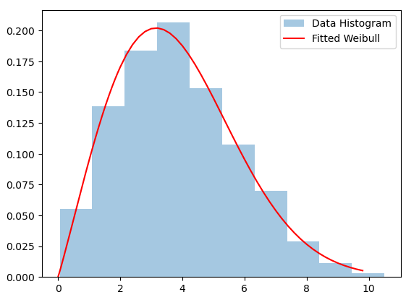

*Figure 4: Fitted Weibull distribution versus generated data histogram*

Test Statistics: 3.4686; Critical Value: 5.9915

Accept H0 that the distribution is a good fit at the given significance level.

True

# perform Goodness of Fit test for all selected distribution types:

dist_types=[x.lower() for x in possible_distributions]

for dt in dist_types:

print('\nfor ',dt, ' distribution type:')

model = dft.Fitting(data, dist_type=dt)

gof_test = gof.Gof(dist_type=dt, par=model.fit())

gof_test.gof(data)

for uniform distribution type:

Test Statistics: 1029.1273; Critical Value: 5.9915

Reject H0, the distribution is NOT a good fit at this significance level.

for exponential distribution type:

Test Statistics: 876.7024; Critical Value: 7.8147

Reject H0, the distribution is NOT a good fit at this significance level.

for normal distribution type:

Test Statistics: 74.5496; Critical Value: 5.9915

Reject H0, the distribution is NOT a good fit at this significance level.

for weibull distribution type:

Test Statistics: 3.4686; Critical Value: 5.9915

Accept H0 that the distribution is a good fit at the given significance level.

for gamma distribution type:

Test Statistics: 43.2718; Critical Value: 5.9915

Reject H0, the distribution is NOT a good fit at this significance level.

In this case, the estimated Maximum Likelihood Estimate (MLE) parameters for the Weibull distribution are the shape parameter (α) with value of approximately 2.0678, and the scale parameter (β) with value of approximately 4.3409. The estimated parameters are successfully aligning with original data.

DistFit explores and suggests possible distributions for the given dataset based on the MLE parameters. In this example, it suggests that the data could be fitted to a variety of distributions, including Uniform, Exponential, Normal, Weibull, and Gamma.

In the subsequent analysis, upon conducting goodness-of-fit tests across all chosen distribution types, it is observed that only the Weibull distribution exhibits a test statistics value of 3.47, which is below the critical value of 5.99. This implies that solely the Weibull distribution adequately fits our original dataset. Conversely, the remaining distribution types yield test statistics exceeding the critical value, leading to the rejection of the null hypothesis for these distributions.

* + 1. **Gamma Distribution**

The Gamma distribution is a versatile distribution that generalizes exponential, chi-squared, and Erlang distributions. The lookup method is a utility for linear interpolation based on a look-up table. It is used in the Gamma_fit method to find the scale parameter (alfa) from a precomputed table based on the sample mean. DistFit estimates the scale ('alpha') and shape ('beta') parameters through the MLE method. It is useful in scenarios requiring the modeling of waiting times, sums of exponential random variables, and various other statistical applications.

import DistFit.distfit as dft

import DistFit.datagen as dgn

import DistFit.gof as gof

# Generate data from a uniform distribution

data_dist = dgn.Datagen(dist_type='gamma', row_count=5000, par=(3.1,5.6), seed=1)

data = data_dist.data_generation()

# Estimate MLE parameters using DistFit

# estimate MLE parameter

model = dft.Fitting(data, dist_type='gamma')

a, b = model.fit()

print("The fitted MLE parameter is %(a).4f %(b).4f." %{'a':a, 'b':b})

# Explore possible distributions using DistFit

possible_distributions = model.guess_distributions()

# Visualize the fitted uniform distribution

model.gamma_plot((a,b))

# Perform Goodness of Fit test using DistFit

gof_test = gof.Gof(dist_type='gamma', par=(a,b))

gof_test.gof(data, k=5)

The fitted MLE parameter is 3.0262 5.7138.

Note: only a limited number of distributions are considered in this library.

The possible distributions for the data are: ['Uniform', 'Exponential', 'Weibull', 'Gamma']

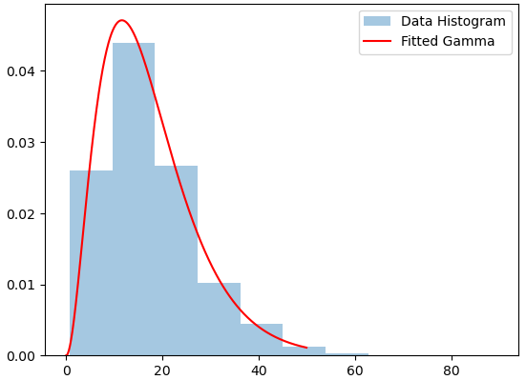

*Figure 5: Fitted Gamma distribution versus generated data histogram*

Test Statistics: 1.7092; Critical Value: 3.8415

Accept H0 that the distribution is a good fit at the given significance level.

True

In this example, the data is generated from a Gamma distribution with given parameters (α=3.1, β=5.6).

The estimated Maximum Likelihood Estimate (MLE) parameters for the Gamma distribution are the shape parameter (α), approximately 3.0262, and the scale parameter (β), approximately 5.7138.

The GoF test assesses the agreement between the observed data and the fitted Gamma distribution. In this instance, the result is True, signifying the acceptance of the null hypothesis (H0). Consequently, at the designated significance level, it implies that the Gamma distribution is deemed a suitable fit for the observed data. It's noteworthy that other suggested distributions are rejected as good fits under the given circumstances.

* 1. **Discrete Distributions**
     1. **Binomial Distribution**

The Binomial distribution extends the Bernoulli distribution to multiple independent trials. It models the number of successes in a fixed number of trials, denoted by 'n'. DistFit estimates the probability of success, 'p', through MLE, and 'n' is user-specified. It is Applicable in scenarios where there are a fixed number of independent trials, such as the number of successful attempts in a series of experiments. The following is an example demonstrating the application of the code for Binomial data.

**import** DistFit**.**distfit **as** dft

**import** DistFit**.**datagen **as** dgn

**import** DistFit**.**gof **as** gof

# Generate data from a uniform distribution

data_dist **=** dgn**.**Datagen**(**dist_type**=**'binomial'**,** row_count**=**2000**,** par**=(**10**,** 0.7**),** seed**=**1**)**

data **=** data_dist**.**data_generation**()**

# Estimate MLE parameters using DistFit

model **=** dft**.**Fitting**(**data**,** dist_type**=**'binomial'**,** n**=**10**)**

**(**n**,**p**)** **=** model**.**fit**()**

**print(**"The fitted MLE parameters are %(n)d %(p).4f." **%{**'n'**:**n**,** 'p'**:**p**})**

# Explore possible distributions using DistFit

possible_distributions **=** model**.**guess_distributions**()**

# Visualize the fitted uniform distribution

model**.**binomial_plot**((**n**,**p**))**

# Perform Goodness of Fit test using DistFit

gof_test **=** gof**.**Gof**(**dist_type**=**'binomial'**,** par**=(**n**,**p**))**

gof_test**.**gof**(**data**,** k**=**10**,** alfa**=**0.05**)**

Note: When estimating p with very rare events and a small n, using MLE estimator leads to p=0 which sometimes is unrealistic and undesirable. In such cases, use alternative estimators.

The fitted MLE parameters are 10 0.6968.

Note: only a limited number of distributions are considered in this library.

The possible distributions for the data are: ['Binomial', 'Geometric', 'Poisson']

If data are binomial, n is at least 10

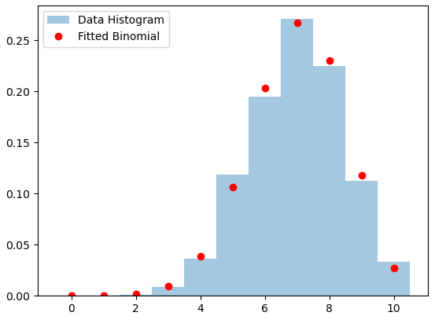

*Figure 6: Fitted Binomial distribution versus generated data histogram*

Test Statistics: 8.3381; Critical Value: 14.0671

Accept H0 that the distribution is a good fit at the given significance level.

True

This code generates a dataset with 2000 observations following a Binomial distribution with parameters n=10 and p=0.7. It then uses the DistFit package to estimate the Maximum Likelihood Estimate (MLE) parameters for a Binomial distribution based on the generated data.

The fitted MLE parameters are determined to be n=10 and p=0.697. The analysis considers a limited set of distributions in the library, and in this case, the possible distributions for the data include 'Binomial', 'Geometric', and 'Poisson'. Additionally, a note emphasizes that if the data is Binomial, n should be at least 10.

A Goodness of Fit (GoF) test is performed, comparing the observed data to the fitted Binomial distribution. The test statistic is calculated as 8.3381, and the critical value at a significance level of 0.05 is 14.0671. The result of the test is True, indicating acceptance of the null hypothesis (H0) at the specified significance level. Therefore, the Binomial distribution is considered a good fit for the observed data.

A potential issue with MLE estimation when dealing with very rare events and a small n, leading to an estimated probability (p) of 0, which might be unrealistic. In such cases, alternative estimators are recommended.

Next, we run the GoF test for the other two possible distributions, Geometric and Poisson. Both are identifies as not a good fit with

# perform Goodness of Fit test for geometric

# first fit data to geometric

model = dft.Fitting(data, dist_type='geometric')

gof_test = gof.Gof(dist_type='geometric', par=model.fit())

gof_test.gof(data)

Test Statistics: 4039.7864; Critical Value: 7.8147

Reject H0, the distribution is NOT a good fit at this significance level.

False

# perform Goodness of Fit test for poisson

# first fit data to poisson

model = dft.Fitting(data, dist_type='poisson')

gof_test = gof.Gof(dist_type='poisson', par=model.fit())

gof_test.gof(data)

Test Statistics: 669.7525; Critical Value: 7.8147

Reject H0, the distribution is NOT a good fit at this significance level.

False

For the Geometric distribution, the test statistic is 4039.7864, and the critical value at a significance level of 0.05 is 7.8147. The result of the test is False, indicating rejection of the null hypothesis (H0) at the specified significance level. Therefore, the Geometric distribution is deemed not a good fit for the observed data.

Similarly, for the Poisson distribution, the test statistic is 669.7525, and the critical value at a significance level of 0.05 is 7.8147. The result of the test is False, indicating rejection of the null hypothesis (H0) at the specified significance level. Consequently, the Poisson distribution is also considered not a good fit for the observed data.

These results suggest that, among the considered distributions (Binomial, Geometric, and Poisson), only the Binomial distribution is identified as a good fit for the generated dataset based on the GoF tests.

* + 1. **Bernoulli Distribution**

The Bernoulli distribution models binary outcomes, such as success or failure in a single trial. DistFit estimates the probability of success, denoted as 'p,' through the MLE method. This distribution is particularly useful for scenarios where there are only two possible outcomes. It is commonly employed in scenarios like coin flips or determining success/failure in a single trial. The following code is an example of using the DistFit package for data generated from a Bernoulli distribution.

import DistFit.distfit as dft

import DistFit.datagen as dgn

import DistFit.gof as gof

# Generate data from a uniform distribution

data_dist = dgn.Datagen(dist_type='binomial', row_count=2000, par=(1, 0.3), seed=1)

data = data_dist.data_generation()

# Estimate MLE parameters using DistFit

model = dft.Fitting(data, dist_type='bernoulli')

fitted_mle_param = model.fit()

print("The fitted MLE parameter is %.4f." %fitted_mle_param)

# Explore possible distributions using DistFit

possible_distributions = model.guess_distributions()

# Visualize the fitted uniform distribution

model.bernoulli_plot(fitted_mle_param)

The fitted MLE parameter is 0.3080.

Note: only a limited number of distributions are considered in this library.

The possible distributions for the data are: ['Bernoulli']

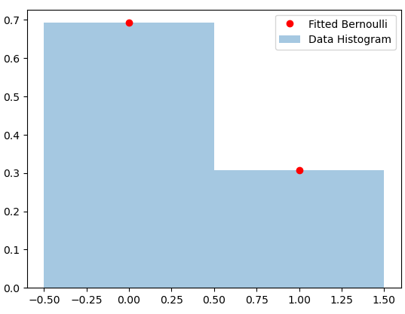

*Figure 7: Fitted Bernoulli distribution versus generated data histogram*

* + 1. **Geometric Distribution**

The Geometric distribution models the number of Bernoulli trials needed to achieve the first success. It is suitable for scenarios where the interest lies in the number of trials required for a specific outcome. DistFit estimates the probability of success, 'p', through MLE. It is Useful in situations where the focus is on the number of trials until a particular event occurs for the first time. A complete example is demonstrated in the following:

import DistFit.distfit as dft

import DistFit.datagen as dgn

import DistFit.gof as gof

# Generate data from a uniform distribution

data_dist = dgn.Datagen(dist_type='geometric', row_count=2000, par=(.42), seed=1)

data = data_dist.data_generation()

# Estimate MLE parameters using DistFit

model = dft.Fitting(data, dist_type='geometric')

fitted_mle_param = model.fit()

print("The fitted MLE parameter is %.4f." %fitted_mle_param)

# Explore possible distributions using DistFit

possible_distributions = model.guess_distributions()

# Visualize the fitted uniform distribution

model.geometric_plot(fitted_mle_param)

# Perform Goodness of Fit test using DistFit

gof_test = gof.Gof(dist_type='geometric', par=(fitted_mle_param))

gof_test.gof(data, k=10)

The fitted MLE parameter is 0.4114.

Note: only a limited number of distributions are considered in this library.

The possible distributions for the data are: ['Binomial', 'Geometric', 'Poisson']

If data are binomial, n is at least 12

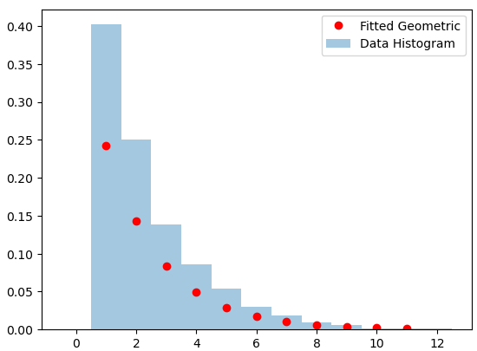

*Figure 8: Fitted Geometric distribution versus generated data histogram*

Test Statistics: 12.4406; Critical Value: 15.5073

Accept H0 that the distribution is a good fit at the given significance level.

True

The code generates a dataset of size 2000 from a Geometric distribution with a probability parameter of 0.42. DistFit is used to estimate the Maximum Likelihood Estimation (MLE) parameter for the Geometric distribution based on the generated data. The fitted MLE parameter is 0.41, indicating the estimated probability parameter for the Geometric distribution. The GoF test statistics value is 12.44 which is less than critical value. Therefore, in this case, the null hypothesis (H0) is accepted, indicating that, at the 0.05 significance level, the Geometric distribution is considered a good fit for the observed data.

* + 1. **Poisson Distribution**

The Poisson distribution models the number of events occurring within fixed intervals. DistFit estimates the rate parameter, '_lambda', through the MLE method. It is Applicable when dealing with count data in scenarios like the number of emails received in an hour. The following code is an example of using the DistFit package and perform a goodness-of-fit analysis for data generated from a Poisson distribution.

import DistFit.distfit as dft

import DistFit.datagen as dgn

import DistFit.gof as gof

# Generate data from a uniform distribution

data_dist = dgn.Datagen(dist_type='poisson', row_count=2000, par=(15), seed=1)

data = data_dist.data_generation()

# Estimate MLE parameters using DistFit

model = dft.Fitting(data, dist_type='poisson')

fitted_param = model.fit()

print("The fitted MLE parameter is %.4f." %fitted_param)

# Explore possible distributions using DistFit

possible_distributions = model.guess_distributions()

# Visualize the fitted uniform distribution

model.poisson_plot(fitted_param)

# Perform Goodness of Fit test using DistFit

gof_test = gof.Gof(dist_type='poisson', par=(fitted_param))

gof_test.gof(data)

The fitted MLE parameter is 14.8965.

Note: only a limited number of distributions are considered in this library.

The possible distributions for the data are: ['Binomial', 'Geometric', 'Poisson']

If data are binomial, n is at least 33

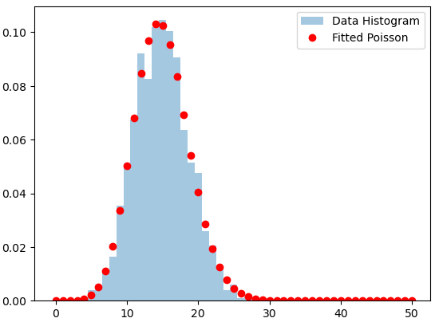

*Figure 9: Fitted Gamma distribution versus generated data histogram*

Test Statistics: 2.3115; Critical Value: 7.8147

Accept H0 that the distribution is a good fit at the given significance level.

True

This code generates a dataset of size 2000 from a Poisson distribution with a mean parameter of 15. The fitted MLE parameter is 14.9, indicating the estimated mean parameter for the Poisson distribution. The GoF test statistics value is 2.31 which is less than critical value. Therefore, in this case, the null hypothesis (H0) is accepted, indicating that, at the 0.05 significance level, the Poisson distribution is considered a good fit for the observed data.

A goodness of Fit test is also conducted for Geometric distribution fit, which is one of the possible distributions for our data.

import DistFit.distfit as dft

# perform Goodness of Fit test for geometric

# first fit data to geometric

model = dft.Fitting(data, dist_type='geometric')

gof_test = gof.Gof(dist_type='geometric', par=model.fit())

gof_test.gof(data, k=10)

Test Statistics: 3493.8377; Critical Value: 15.5073

Reject H0, the distribution is NOT a good fit at this significance level.

False

The results indicate that, based on the statistical test, the Geometric distribution is not a good fit for the data, which aligns with our expectation.

1. **Requirements**

In conjunction with the indispensable modules (datagen, distfit, and gof), DistFit mandates the installation of specific Python libraries to guarantee the efficient and error-free execution of the package. These prerequisites encompass a suite of essential tools and utilities tailored to augment the package's overall functionality. Therefore, it is imperative to ensure that the following dependencies are installed on your Python environment:

* **Python version**: DistFit is designed to seamlessly integrate with Python 3 versions. It is crucial to have Python installed, and for optimal compatibility and feature support, consider using the latest stable release.
* **Numpy**: At the heart of numerical operations in Python, NumPy is an indispensable library for array manipulations and mathematical computations. DistFit leverages NumPy's capabilities to enhance the efficiency of data processing and analysis.
* **Scipy**: An extension of NumPy, SciPy extends the functionality of scientific computing in Python. DistFit relies on SciPy for its comprehensive statistical distributions and advanced hypothesis testing.
* **Pandas**: Pandas offers a powerful framework for data manipulation and analysis. DistFit takes advantage of Pandas to seamlessly handle tabular data structures, providing flexibility in data input and manipulation.
* **Matplotlib**: Matplotlib stands out as a versatile plotting library that facilitates the creation of visually appealing and informative graphs. DistFit integrates Matplotlib to generate graphical representations of distribution fitting outcomes, enhancing the interpretability of results.
* **Statsmodels**: DistFit incorporates Statsmodels, a statistical modeling library, to enable advanced statistical analyses and diagnostics. This ensures a robust and comprehensive approach to exploring data distributions.
* **Scipy.stats**: The Scipy.stats module is a valuable resource for an extensive range of statistical functions. DistFit makes use of Scipy.stats to access various probability distributions and perform essential statistical calculations.

1. **Challenges and Future Updates**

While the DistFit Python package offers a robust methodology for fitting data to various probability distributions, like any software project, it may encounter challenges that is worth to state in this article. Some potential future updates can help mitigate the challenges associated with the DistFit project. Here are some challenges that might be addressed through future enhancements to the project:

* **Distribution Selection**: Determining the appropriate probability distribution for a given dataset can be subjective and complex. Providing additional guidance or automated methods for users to assist in selecting suitable distributions can be helpful.
* **Handling Large Datasets**: Processing large datasets may lead to performance issues or memory constraints. For future updates, we can plan to optimize algorithms and explore the integration of parallel processing techniques. These enhancements aim to significantly improve the package's performance, particularly when dealing with larger datasets. The optimization efforts will focus on refining computational efficiency, and parallel processing strategies will be investigated to leverage the capabilities of multi-core systems, ensuring faster and more scalable data fitting processes.
* **Model Interpretability**: Interpreting the results of fitted models, especially for complex distributions, can be challenging for non-expert users. Adding more examples, and visualizations can aid users in interpreting the results of the fitted models.
* **User Interface Design**: If the package is intended for a broad audience, creating an intuitive and user-friendly interface might be challenging. We can plan to develop a user-friendly interface, possibly through a graphical user interface (GUI) or interactive visualization tools, to make the package accessible to a wider audience.
* **Maintenance and Updates**: Keeping the package up-to-date with the latest versions of dependencies and addressing issues reported by users can be challenging. We will Establish a maintenance plan, encourage user feedback, and actively address reported issues to ensure the package remains reliable and relevant.
* **Documentation and Educational Resources**: Users may face challenges understanding the concepts of probability distributions and how to use the package effectively. We will improve our work with provide more documentation, tutorials, and educational resources to assist users in understanding both the statistical concepts and the practical usage of the package.

1. **Conclusion**

The methodology provides a systematic and versatile approach to fitting data to a range of distributions, empowering users with tools for exploratory data analysis and statistical modeling. The visualizations aid in understanding how well the fitted distributions align with the observed data. DistFit emerges not only as a distribution-fitting tool but as a comprehensive guide to the intricate world of probability distributions. By navigating through each distribution type and their parameters, users can harness the full potential of DistFit, transforming data analysis into a seamless and insightful journey.

The gof module, or Goodness of Fit, is a critical component that enables users to assess the suitability of the fitted distribution. Through statistical tests and comparison with critical values, the module helps users make informed decisions about accepting or rejecting the null hypothesis, indicating whether the chosen distribution is a good fit for the observed data. Note that the GoF test used in this library is approximate and if the test statistics is close to the critical value, caution should be exercised.

While DistFit offers a powerful and convenient tool for distribution analysis, it is essential to note that the results are contingent on the assumptions made during the modeling process. Users should exercise caution and consider the specific characteristics of their datasets when interpreting the outcomes.

In summary, DistFit provides a valuable resource for researchers, data scientists, and statisticians seeking a comprehensive and user-friendly solution for probability distribution fitting in Python. Through the intricate details provided in this paper, users can navigate the package with confidence, harnessing the power of DistFit to uncover hidden patterns and gain valuable insights into the underlying nature of their data.

1. **References**

Law, A. M. (2015). Simulation modeling and analysis (5th Edition). New York: Mcgraw-Hill